**MARKING SCHEME OF ANATOMY II**

1. **briefly discuss any five anatomical narrowing’s of the esophagus**

**upper esophageal sphincter**[inferior pharyngeal constrictor](https://www.kenhub.com/en/library/anatomy/inferior-pharyngeal-constrictor).

**lower esophageal sphincter**,  
**cardiac sphincter**.

1. **Name the components of lymphatic system**

The lymphatic system comprises

lymph,

lymphatic capillaries,

lymphatic vessels,

lymphatic nodes,

lymphatic ducts.

It also consists of other organs and tissues like the spleen,

thymus, tonsils, Peyer’s patches, etc. Fig: Human Lymphatic System

1. **Five difference between a vein and an artery**

|  |  |
| --- | --- |
| artery | vein |
| Arteries are thick and possess 3 layered walls of muscles and elastin. | Veins have thin walls with few elastic fibres. A vein also consists of three layers as an artery. |
| Since arteries are vital for the blood flow to the body, they are located deeper in the body, closer to the skin and hence remain protected by the skin tissues. | Veins are located close to the skin surface and are at a distance from the corresponding artery. |
| Fair, clear and distinct | Convergent, difficult to follow interconnections. Connections show irregular networks. |
| Supply can be predicted in arteries. | Similar to arteries, exception; Dural sinuses and hepatic portal circulatory system. |
| The lumen in the arteries is narrow. no valves | Valves are present in a vein and the lumen is wider. |

1. **Draw the cross section of small intestine. (5mks)**

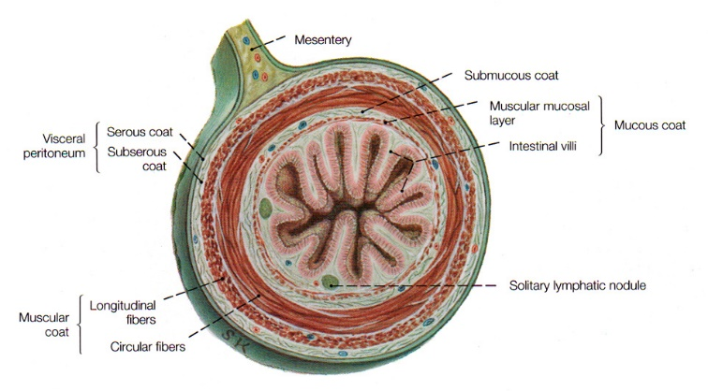

1. **Summarize the arterial blood vessels that supply the kidney up to capillaries (5mks)**

In the abdomen, the **renal arteries** branch from the abdominal aorta inferior to the **superior mesenteric artery** and extend laterally toward the kidneys. Just before reaching the kidney, each renal artery divides into **five segmental arteries,** which provide blood to the various regions of the kidney. Each segmental artery enters the hilus of the kidney and divides into several **interlobar arteries**, which pass through the renal columns between the renal pyramids and carry blood toward the exterior of the kidney. At the junction between the renal cortex and renal medulla, the **interlobar arteries** form the **arcuate arteries**, which turn to follow the contours of the renal pyramids. From the **arcuate arteries** several branches, known as **interlobular arteries,** separate at right angles and extend through the renal cortex toward the exterior of the kidney. Each **interlobular artery** forms several **afferent arterioles**, which end in a bed of **capillaries known as glomeruli** where blood is filtered to form urine.

1. **Describe any three types of muscles**

There are three types of muscle tissue in the body. They are:

* **Skeletal:**As part of the [musculoskeletal system](https://my.clevelandclinic.org/health/articles/12254-musculoskeletal-system-normal-structure--function), these muscles work with your bones, tendons and ligaments. Tendons attach skeletal muscles to bones all over your body. Together, they support the weight of your body and help you move. You control these voluntary muscles. Some muscle fibers contract quickly and use short bursts of energy (fast-twitch muscles). Others move slowly, such as your back muscles that help with [posture](https://my.clevelandclinic.org/health/articles/4485-back-health-and-posture).
* **Cardiac:**These muscles line the heart walls. They help your heart pump blood that travels through your cardiovascular system. You don’t control cardiac muscles. Your heart tells them when to contract.
* **Smooth:**These muscles line the insides of organs such as the bladder, stomach and intestines. Smooth muscles play an important role in many body systems, including the [female reproductive system](https://my.clevelandclinic.org/health/articles/9118-female-reproductive-system), [male reproductive system](https://my.clevelandclinic.org/health/articles/9117-male-reproductive-system), [urinary system](https://my.clevelandclinic.org/health/articles/21197-urinary-system) and [respiratory system](https://my.clevelandclinic.org/health/articles/21205-respiratory-system). These types of muscles work without you having to think about them. They do essential jobs like move waste through your intestines and help your lungs expand when you breathe.

1. **Describe the difference between the right and the left lung**

The **key difference** between right and left lung is that the **right lung consists of three lobes while the left lung consists of two lobes.**Moreover, the right lung connects to the trachea by two bronchi while the left lung connects to the trachea by a single bronchus.

1. **State five male reproductive organs**

Penis

Scrotum

Testicles

Epididymis

Vas deferens

Ejaculatory duct

Urethra

Seminal vesicles

**LONG ANSWER QUESTION**

* 1. **With a well labeled diagram illustrate the alimentary system (20 mks)**

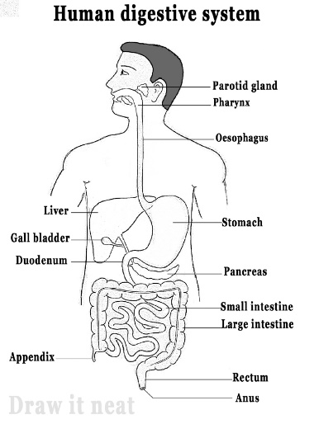

* 1. **Describe the endocrine gland clearly stating the types of hormones they produce and their function (20mks)**

Hypothalamus

This gland is a part of the brain that consists of neurosecretory cells. They connect both the nervous and the endocrine system. The hypothalamus secretes various releasing hormones like gonadotropin-releasing hormones and [**growth hormone**](https://byjus.com/biology/growth-hormone/)-releasing hormones. These hormones act on the pituitary gland to stimulate other glands

## Pituitary Gland

The pituitary gland is the master gland. It is a pea-sized gland that is located at the bottom of the brain. It controls and regulates other glands in the body. Hormones released by this gland are growth hormone, thyroid-stimulating hormone, LH, FSH etc.

## Pituitary Gland

The pituitary gland is the master gland. It is a pea-sized gland that is located at the bottom of the brain. It controls and regulates other glands in the body. Hormones released by this gland are growth hormone, thyroid-stimulating hormone, LH, FSH etc

## Pineal Gland

This gland is also located in the brain. It releases the hormone called melatonin which regulates the wake-up and sleep clock and helps in [**immunity**](https://byjus.com/biology/immunity/) etc.

## Thyroid gland

This is a butterfly-shaped paired gland located in the neck region. It releases the hormones triiodothyronine (T3) and thyroxine (T4). These hormones regulate body metabolism. Iodine is vital for thyroxine synthesis. Its deficiency leads to a disease called goitre.

## Parathyroid Gland

This gland is located near the Thyroid gland in the neck region. The hormone released by this gland is called Parathyroid hormone, which regulates calcium and phosphorus level in bones.

## Pancreas

The pancreas is an endocrine as well as an exocrine gland. That is why the Pancreas is also known as a mixed gland. The pancreas secretes hormones like glucagon and insulin; these two hormones balance the blood sugar level in the body. Other hormones secreted are somatostatin and pancreatic polypeptide.

## Adrenal Glands

Adrenal glands have two regions known as the adrenal cortex and adrenal medulla.

The cortex region of the adrenal gland secretes the hormones cortisol, aldosterone, and androgens while the medulla region secretes the hormones adrenaline and noradrenaline. Adrenaline is the hormone responsible for the fight or flight response of the body in times of emergency.

## Gonads

Gonads are reproductive glands present in males and females. The male gonad is the pair of testes which secretes the hormone testosterone. This is responsible for the secondary sexual characteristics in males. The female gonad consists of a pair of ovaries. They secrete two hormones estrogen and progesterone. Both of these regulate secondary sexual characteristics in females.